3.3.3 Number of books and chapters in edited volumes/books published and papers published in national/ international conference proceedings per teacher during year
1
Dr. Anjana Bhatia
E Book on Plant Biodiversity and Environment Conservation
978-93-83790-414

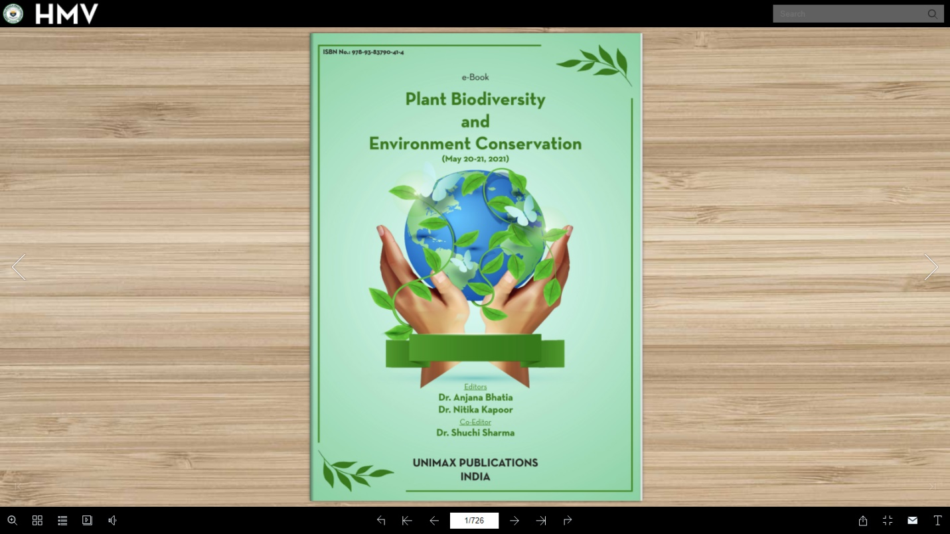
Unimax Publications India
2
Dr. Nitika Kapoor
E Book on Plant Biodiversity and Environment Conservation
978-93-83790-414

Unimax Publications India
3
Dr. Shuchi Sharma
E Book on Plant Biodiversity and Environment Conservation
978-93-83790-414

Unimax Publications India
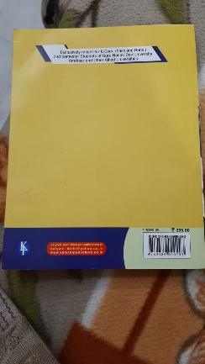
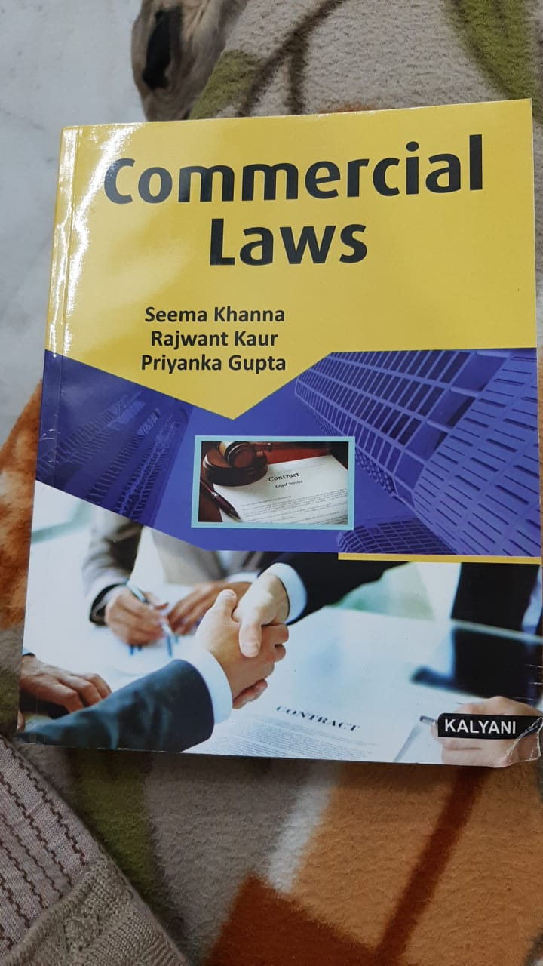
4
Dr Seema Khanna

Commercial Law

978-93-8990-029

Kalyani publisher

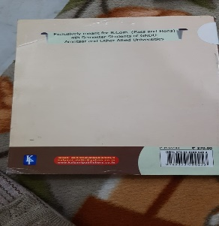
5
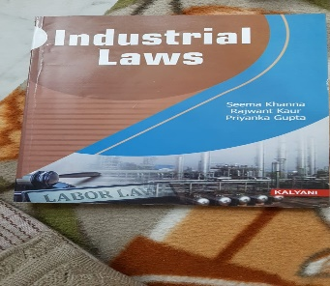
Dr Seema Khanna

Industrial Laws

978-93-5359-253

Kalyani publisher
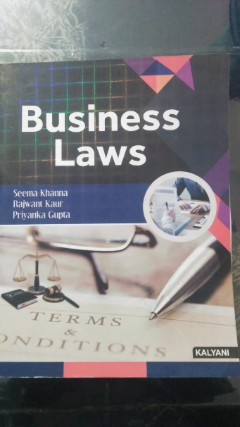
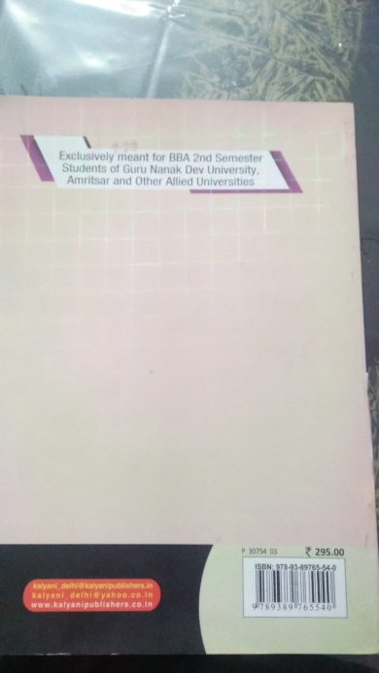
6
Dr Seema Khanna

Business Laws

978-93-8976-554

Kalyani publisher

7
Dr. Nitika Kapoor

Kapoor, N., Kapoor, B. and Bhardwaj, R. (2020). Brassinosteroids mediated salinity stress amelioration in maize. International book market service Ltd.,

ISBN: 978-620-2-81574.

Lambert Academic Publishing,
8
Dr. Seema Marwaha

Covid 19 and Immunity Booster Plantsin E Book on Plant Biodiversity and Environment Conservation
978-93-83790-414


Unimax Publications India
9
Mr. Ravi Kumar

E Book on Plant Biodiversity and Environment Conservation
978-93-83790-414

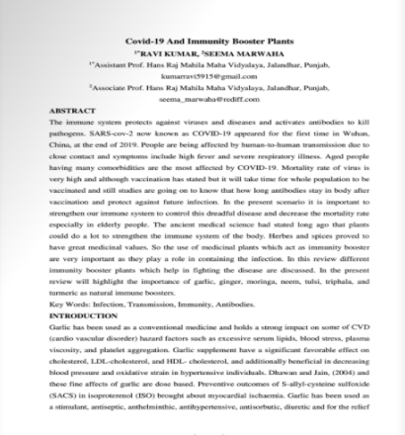
Unimax Publications India
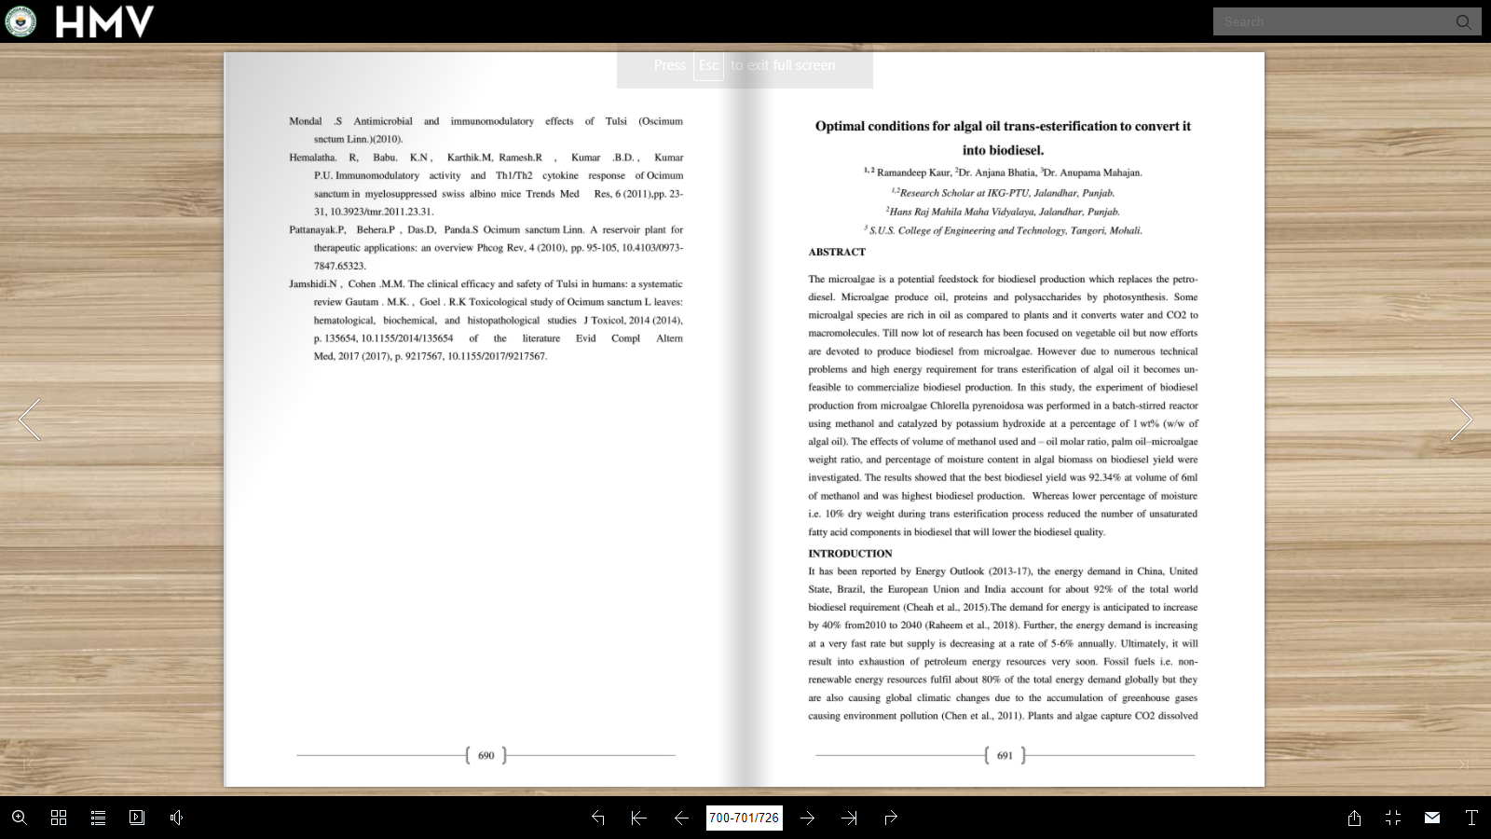
10
Dr. Anjana Bhatia
Optimal conditions for algal oil trans esterification to convert it into Biofuel in E Book on Plant Biodiversity and Environment Conservation
978-93-83790-414

Unimax Publications India
11
Mrs.Ramandeeep Kaur

Optimal conditions for algal oil trans esterification to convert it into Biofuel in E Book on Plant Biodiversity and Environment Conservation
978-93-83790-414

Unimax Publications India
12
Mr. Sushil Kumar

Phytoremediation -A Review “in E Book on Plant Biodiversity and Environment Conservation
978-93-83790-414

Unimax Publications India
13
Ms. Harpreet

Phytoremediation -A Review “in E Book on Plant Biodiversity and Environment Conservation
978-93-83790-414

Unimax Publications India
14
Dr. Simmi Garg

Phytoremediation -A Review “in E Book on Plant Biodiversity and Environment Conservation
978-93-83790-414

Unimax Publications India
15
Dr. Sakshi

Protective efficacy of dietry neringenin against cadmium induced toxicity Book on Plant Biodiversity and Environment Conservation
978-93-83790-414

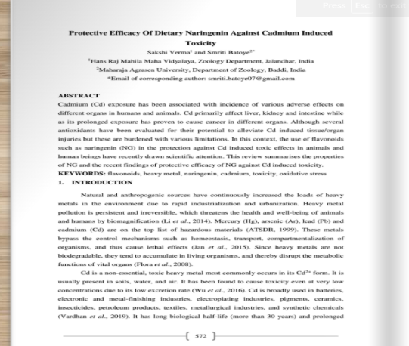
Unimax Publications India
16
Dr. Shaveta Chauhan

Medical Orchids of Shimla Hills, Their uses and conservation status in E Book on Plant Biodiversity and Environment Conservation
978-93-83790-414

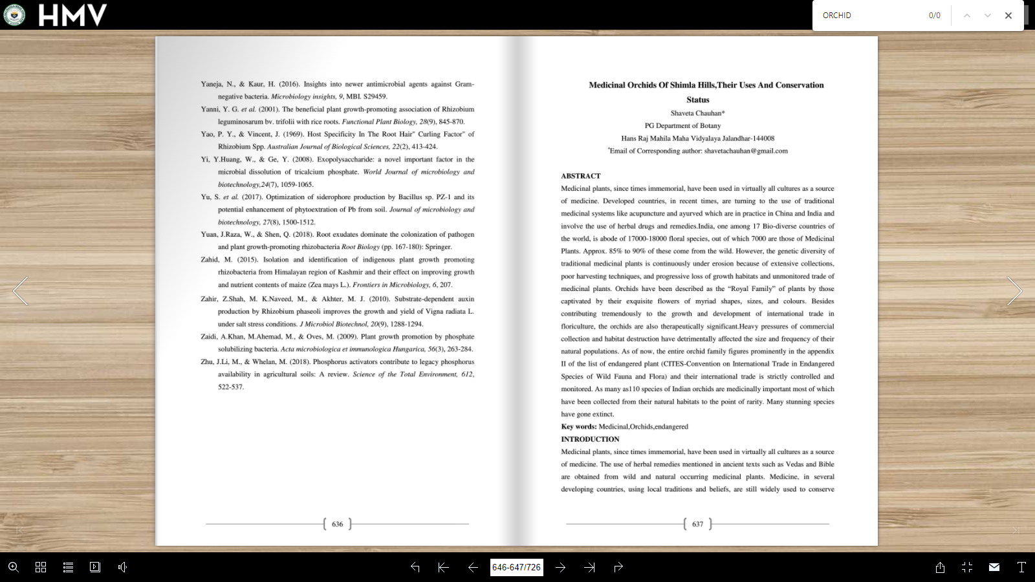
Unimax Publications India
17
Dr.Anjana Bhatia

Bioinformatics analysis of genes involved in triacylglycerol biosynthesis in angiosperms and their relevnace to biofuel production E Book on Plant Biodiversity and Environment Conservation
978-93-83790-414

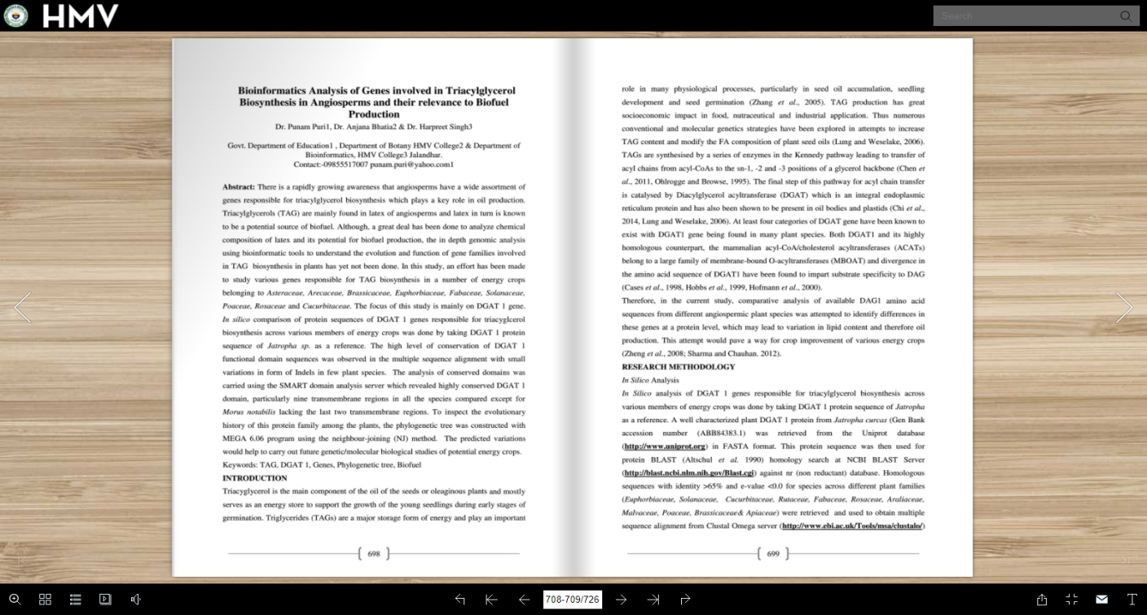
Unimax Publications India
18
Dr . Harpreet Singh

Bioinformatics analysis of genes involved in triacylglycerol biosynthesis in angiosperms and their relevnace to biofuel production E Book on Plant Biodiversity and Environment Conservation
978-93-83790-414

Unimax Publications India
19
Mrs .Mamta

The Non-Familial Affiliations in Short Stories by Tagore and Gurdial Singh: A Comparative Study of Relationships in Book South Asian Literature and Culture Social Inclusion and Exclusion

20
Dr . Harpreet Singh

Smart learning solutions for combating Covid-19. In: Explainable Artificial Intelligence for Smart Cities

9781003172772

CRC Press

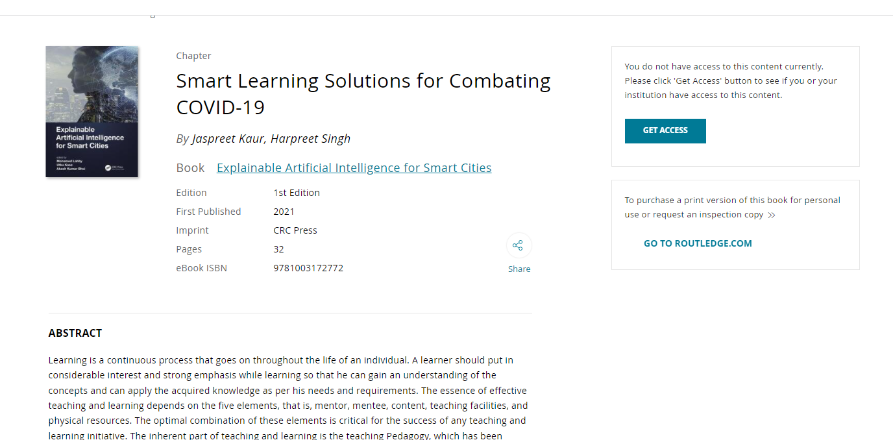
21
Dr . Jaspreet Kaur
Smart learning solutions for combating Covid-19. In: Explainable Artificial Intelligence for Smart Cities Explainable Artificial Intelligence for Smart Cities, CRC Press
9.781E+12

22
Dr. Shaveta Chauhan
Studying regenerative competence of Satyrium
nepalense D.Don through leaf segments in vitro

23
Dr. Shaveta Chauhan
Organic farming and health benefits in Organic farming and sustainable development
9.78939E+12

Dr. Nitika Kapoor
Kapoor, N. Sharma, P. and Verma, S. (2021) Remediation of Heavy Metal-Contaminated Soil. In: Microbes and Microbial Biotechnology for Green Remediation, Ahmed, J. (Ed).

Elsevier Inc. (In press).
Dr. Nitika Kapoor
Handa, N., Arora, U., Arora, N., Kaur P., Kapoor, D. and Bhardwaj, R. (2021) Role of metabolites in abiotic stress tolerance in legumes. In: Abiotic stress and Legumes (1st edition), V.P. Singh, S. Singh, D.K. Tripathi, S.M. Prasad and R. Bhardwaj (Eds) Chapter 11, pp. 245-276
9780128153550
Academic Press, Elsevier,
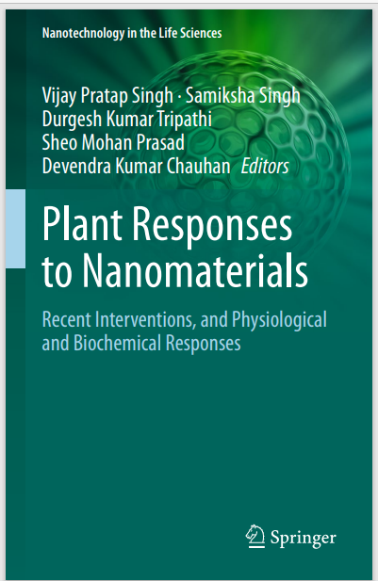
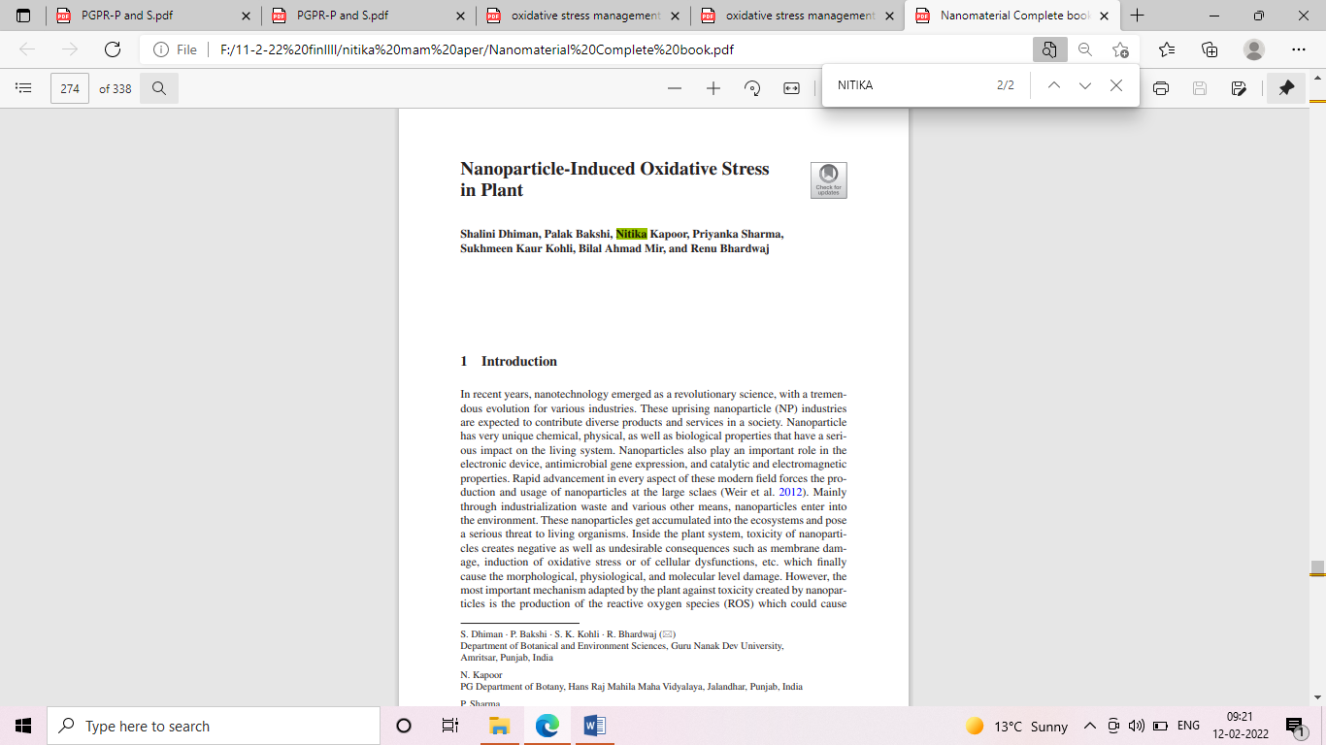
Dr. Nitika Kapoor
Dhiman, S., Bakshi, P., Kapoor, N., Sharma, P., Kholi, S.K., Mir, B.A., and Bhardwaj, R. (2021) Nanoparticle-induced oxidative stress in plants. In: Plant responses to nanomaterials: Recent Interventions, and Physiological and Biochemical Responses (1st edition), V. Singh, S. Singh, D.K. Tripathi, S.M. Prasad and D.K, Chauhan (Eds) Academic Press,
ISBN: 978-3-030-36740-4.
Springer Nature, Switzerland Chapter 12
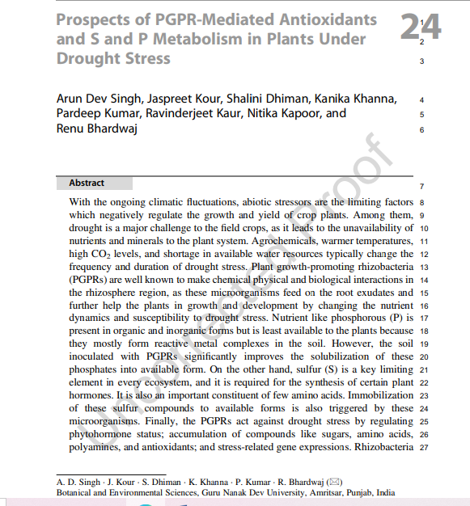
Dr. Nitika Kapoor
Singh, A.D., Kour, J., Dhiman, S., Khanna, K., Kumar,P., Kaur, R., Kapoor, N. and Bhardwaj, R. (2021)Prospects of PGPR-Mediated Antioxidants and S and P Metabolism in Plants Under Drought Stress. In: Antioxidants in Plant-Microbe Interaction (1st edition), H.B. Singh, A. Vaishnav, R.Z. Sayyed (Eds.) Ch 24, r ISBN 978-981-16-1349-4
ISBN 978-981-16-1350-0,
Springer Nature Singapore Chapter DOI 10.1007/978-981-16-1350-0_24, eBook Hardcove
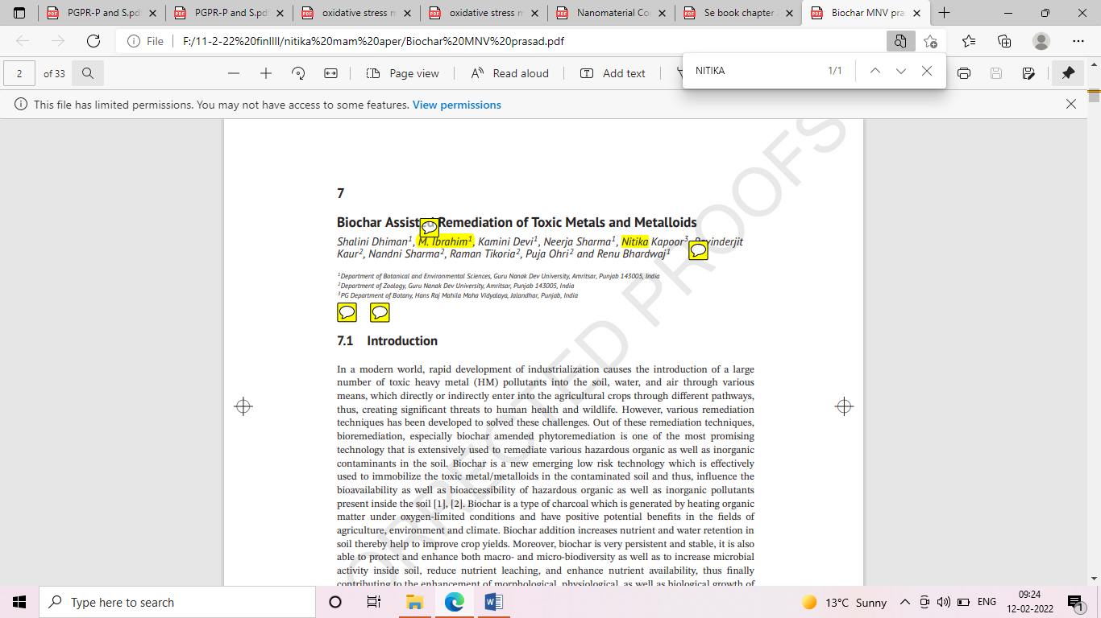
Dr. Nitika Kapoor
Dhiman,S., Ibrahim, M., Devi, K., Sharma, N., Kapoor, N., Kaur, R., Sharma, N., Tikoria, R., Ohri, P. and Bhardwaj, R. (2021). Biochar Assisted Remediation of Toxic Metals and Metalloids. In: Handbook of Assisted and Amendment-Enhanced Sustainable Remediation Technology, (1st Edition), M. N. V. Prasad (Ed).
(ISBN13: 9781119670384)
John Wiley & Sons Ltd. New York Pp. 131-162
ISBN: 1119670381 . Chapter 7
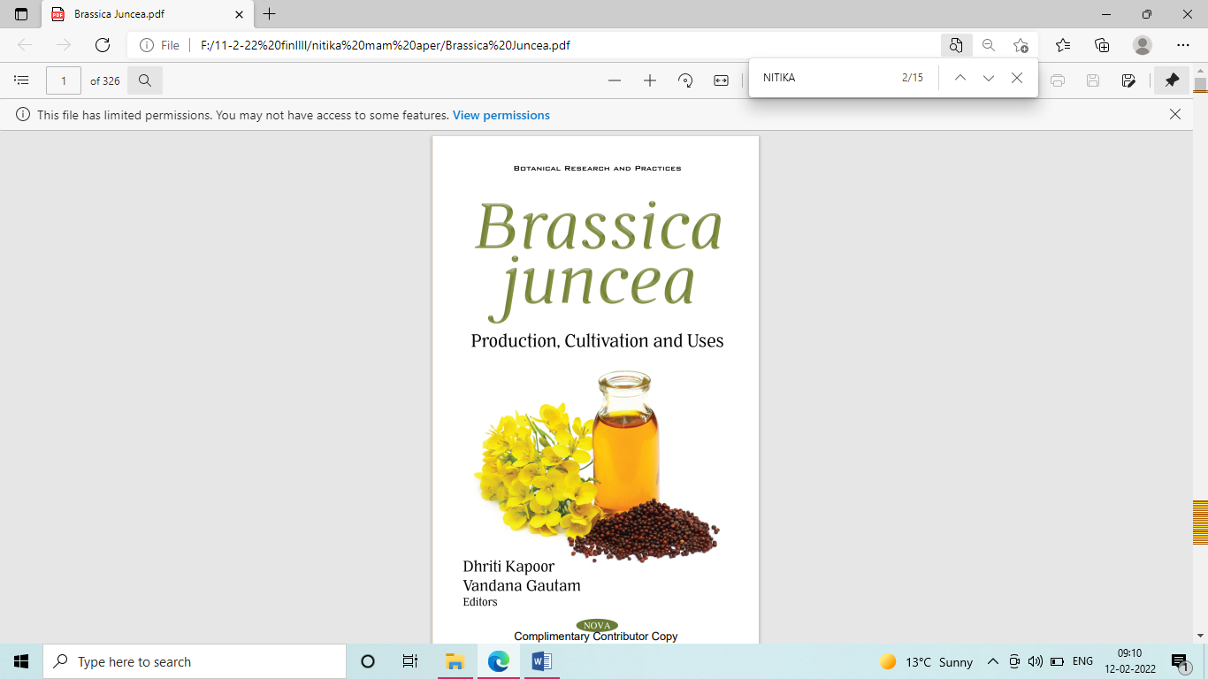
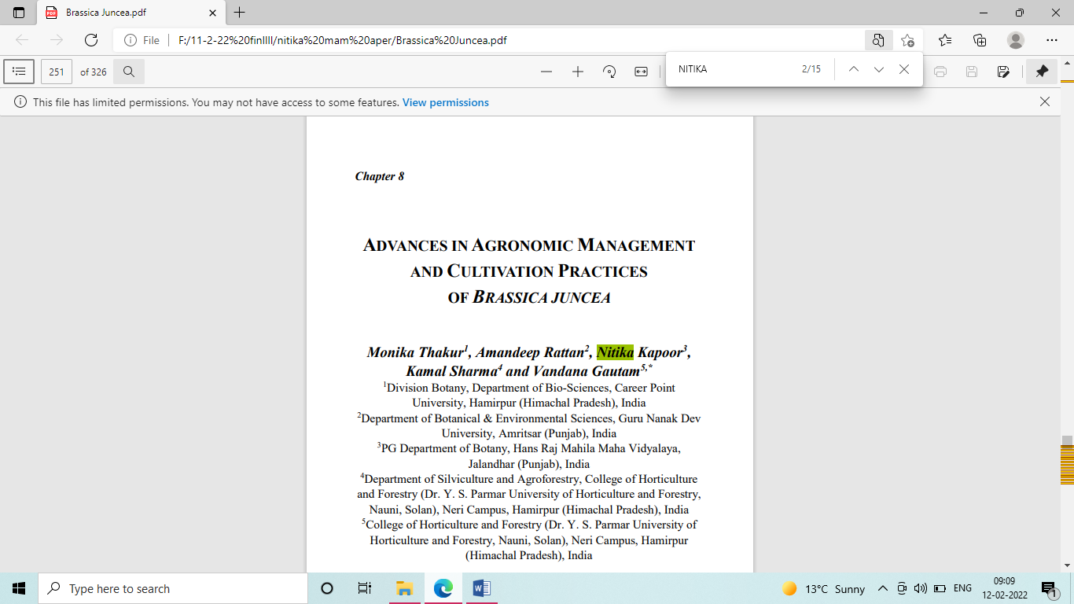
Dr. Nitika Kapoor

Thakur, M, Rattan A, Kapoor N, Sharma, K. and Gautam, V. (2021). Advance in Agronomic management and cultivation Practices of Brassica juncea. In: Brasica juncea: Production, Cultivation and Uses (Eds. D Kapoor, V. Gautam). pp. 235-262,
. ISBN- 978-1-53619-241-4
Nova publication, New York, USA

Dr. Nitika Kapoor
Kapoor, N. (2021). Mechanisms of Heavy metal detoxification and tolerance in higher plants. In: Agriculture and Forestry: Current trends, perspectives, issues-III, S. Rout (Ed),
, ISBN: 978-93-5437-260-5
Immortal Publications
Dr. Nitika Kapoor
. Dhiman,S., Bakshi, P. Singh, A.D., Bhardwaj, T. Sharma, N., Kapoor, N., Kapoor, D., Kaur, R., Arora, U., Sharma, A., Mir, B.A. and Bhardwaj, R. (2021). Role of Hydrogen sulfide and Ca signaling in abiotic stress tolerance in plants In: Hydrogen Sulfide in Plant Biology- Past and Present (1st Edition), S. Singh, V.Singh, D. Tripathi, S. Prasad and D. Chauhan (Eds)
ISBN: 9780323858625.
Academic Press, Elsevier, Paperback
Dr. Nitika Kapoor
Kaur J., Khanna, K., Bakshi, P. Sharma, I., Ohri, P. Mir, B.A., Kapoor, N. and Bhardwaj, R. (2020) Role of Beneficial Microbes in the Molecular Phytotoxicity of Heavy Metals. In: Faisal M., Saquib Q., Alatar A.A., Al-Khedhairy A.A. (eds) Cellular and Molecular Phytotoxicity of Heavy Metals. Nanotechnology in the Life Sciences.
Print ISBN 978-3-030-45974-1 Online ISBN 978-3-030-45975-8
Springer, Cham. https://doi.org/10.1007/978-3-030-45975-8_13 , pp. 227-262
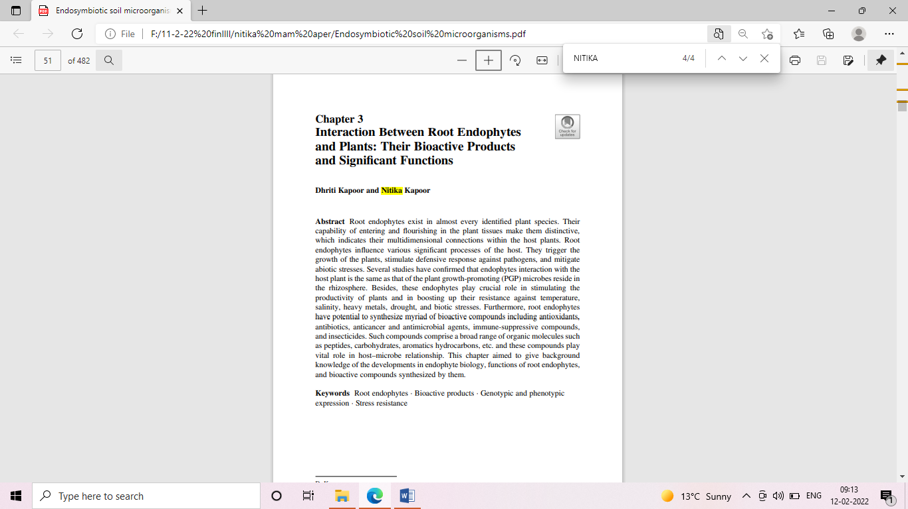
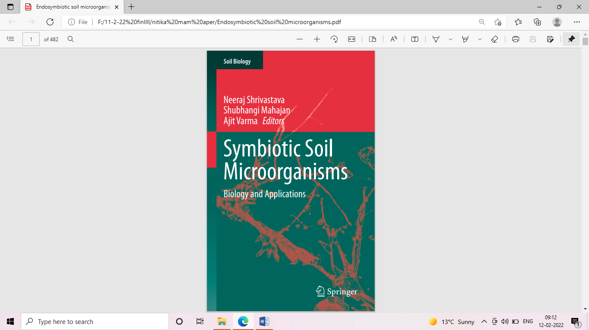
Dr. Nitika Kapoor
Kapoor, D and Kapoor, N (2020). Interaction Between Root Endophytes and Plants: Their Bioactive Products and Significant Functions" In : Symbiotic Soil Microorganisms, Soil Biology, Vol. 60. (Eds: Neeraj Shrivastava et al.).
ISBN: 978-3-030-51915-5, ISBN (e Book): 978-3-030-51916-2
Publisher: Springer Nature Switzerland https://doi.org/10.1007/978-3-030-51916-2_3

